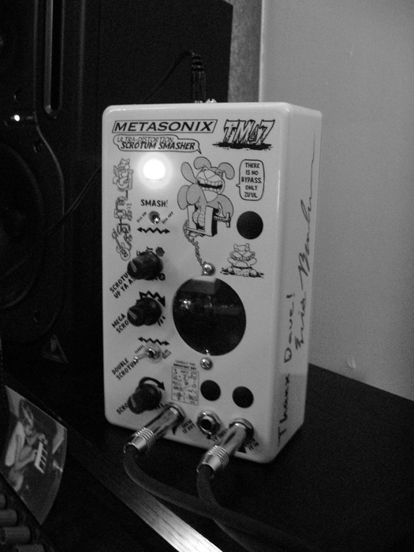
TM-7 SCROTUM SMASHER
by Dave Lovelace
owner's manual ver. 1.0
copyright 2007 METASONIX, all rights reserved

READ THIS, DAMMIT!!!!!!!!!

CAUTION: to reduce the risk of electrical shock, do not remove the bottom cover.

HIGH VOLTAGE INSIDE. No user serviceable parts inside. Refer servicing to qualified service personnel.

WARNING: to reduce the risk of fire or electrical shock, do not expose the TM-7 to rain or moisture. (DO NOT STICK IT UP YOUR BUTT!!! It won't fit!)

DETAILED SAFETY INSTRUCTIONS: All the safety and operation instructions must be read before the TM-7 is operated. If you don't read and HEED them, you are a MORON and you deserve to have your PENIS AMPUTATED.

RETAIN INSTRUCTIONS: The safety and operating instructions should be retained for future reference.

HEED WARNINGS: All warnings on the TM-7 and in the operating instructions should be adhered to.

FOLLOW INSTRUCTIONS: All operating instructions should be followed.

WATER AND MOISTURE: The TM-7 should not be used near water (e.g. near a bathtub, washbowl, kitchen sink, laundry tub, in a wet basement, near a swimming pool etc., ya stupid bastard). Care should be taken so that liquids are not spilled onto or near the enclosure.

VENTILATION AND COOLING: The TM-7 normally operates warm to the touch. It MUST be situated so that its location or position does not interfere with convective cooling. The TM-7 MUST NOT be used on a bed, sofa rug or similar surface which may prevent proper cooling. It is NOT a toy. If the TM-7 is mounted in a rack or other built-in installation, space must be left around it to allow convection from the case.

HEAT: The TM-7 MUST be situated away from heat sources such as radiators, heat registers, stoves, or other devices (including power amps) that produce heat.

POWER SOURCE: The TM-7 should be connected to a power supply ONLY of the type described in the operating manual or as marked on the TM-7.
DO NOT APPLY DC POWER TO THE TM-7, YOU MORON!!!!

POWER CORD PROTECTION: Power supply cords should be routed so that they are not likely to be walked on or pinched by items placed upon or against them. Don't burn your house down, shitmonkey.

CLEANING: The TM-7 should only be cleaned with a soft cloth moistened with water. Unplug the power supply before attempting to clean.

NON-USE PERIODS: The power supply of the TM-7 should be unplugged from the outlet when left unused for a long period of time.

DAMAGE OR TUBE REPLACEMENT REQUIRING SERVICE:

The TM-7 should be serviced by qualified service personnel when:
-The power supply or plug has been damaged;
-The TM-7 has been dropped, physically damaged, or subjected to force;
-Liquid has been spilled onto the TM-7 or it has been exposed to rain;
-The TM-7 does not appear to operate normally or exhibits a marked change in performance.

SERVICING: The user should NOT attempt to service the TM-7. All servicing should be referred to qualified service personnel.
THIS MEANS YOU, STINKY!!!

METASONIX LIMITED WARRANTY and standard legal disclaimer

Thank you (yeah, right) for purchasing this Metasonix product. The following terms and conditions apply:
1. Warranty period is for 90 days from date of purchase with proof of purchase submitted. Warranty covers electrical failure of vacuum tubes and gas-filled tubes, except in cases explained in 3 below.
2. Operating instructions must be followed. This device was intended ONLY for use by AUDIO AND MUSIC PROFESSIONALS.
IT IS NOT INTENDED FOR USE BY ORDINARY CONSUMERS!!
Product must not have been damaged as a result of defacement, misuse, abuse, neglect, accident, destruction or alteration of the serial number, improper electrical voltages or currents, repair, alteration or maintenance by any person or party other than our own service facility or an authorized service center, use or installation of non-Metasonix replacement parts in the product, or the use of this product outside of the U.S.A. or Canada, or modification of the product in any way, or incorporation of the product into any other products, or damage to the product caused by accident, fire, floods, lightning, or acts of God, or any use violative of instructions furnished by Metasonix.
3. Obligations of Metasonix shall be limited to repair or replacement with same or similar unit, at our option. To obtain repairs under this warranty, present the product and proof of purchase (e.g. bill or invoice) to the authorized Metasonix service center, transportation charges prepaid. When returning the product for repair, please pack it very carefully, preferably using the original packaging materials. Please also include an explanatory note.
IMPORTANT:
To save yourself unnecessary cost and inconvenience, please check carefully that you have fully read and followed the instructions in this instruction manual.
This warranty is in lieu of all other expressed warranties, obligations or liabilities. ANY IMPLIED WARRANTIES, OBLIGATIONS, OR LIABILITIES, INCLUDING BUT NOT LIMITED TO THE IMPLIED WARRANTIES OF MERCHANTABILITY AND FITNESS FOR A PARTICULAR PURPOSE, SHALL BE LIMITED IN DURATION TO THE DURATION OF THIS WRITTEN LIMITED WARRANTY. Some states do not allow limitations on how long an implied warranty lasts, so the above limitations may not apply to you. IN NO EVENT SHALL WE BE LIABLE FOR ANY SPECIAL, INCIDENTAL OR CONSEQUENTIAL DAMAGES FOR BREACH OF THIS OR ANY OTHER WARRANTY EXPRESS OR IMPLIED, WHATSOEVER. Some states do not allow the exclusion or limitation of special, incidental or consequential damages, so the above limitation may not apply to you. This warranty gives you specific legal rights, and you may also have other rights which vary from state to state.
METASONIX shall not be held liable for any incidental, consequential, or direct damages or expenses associated with the use or misuse of the TM-7. The audio output of the TM-7 is capable of damaging some types of solid-state audio equipment; such use is entirely at the risk of the user. METASONIX does not guarantee that any of its products are designed for any particular use or purpose. The entire risk of suitability and performance of this product lies with the user. Products manufactured and/or sold by METASONIX are not authorized for use as critical components in devices used in life support and other systems whose failure or performance could result in compromised safety or danger to life or property. Don't perform surgery with a TM-7. It has no healing magic.
Did we mention the DANGEROUS HIGH VOLTAGES inside the TM-7?
DO NOT OPEN THE TM-7 unless you're a service technician.

NOTE: All sales are FINAL, especially custom designs. Only a Metasonix authorized dealer is permitted to return products to Metasonix for a refund or exchange.

WHAT IT DOES
The TM-7 is basically a mean, angry preamp made of three vacuum tubes. Plus a feedback loop which makes the preamp unstable.

The first tube is a 6AK5. It was used as an IF amplifier in military radios and suchlike. We use it as a preamp—a BAD preamp. The SCROTUM knob controls input volume. (No, you can't turn it fully down. This is intentional—because it interacts with the DOUBLE SCROTUM switch. Turning down the input won't silence the awful noise and oscillation. Ha ha ha.)

Then the signal goes through ANOTHER 6AK5. The MEGA SCROTUM knob affects its gain. So, MEGA SCROTUM is basically a drive control. MEGA SCROTUM may be turned fully down, if you wish (it may or MAY NOT fully silence the TM-7).

Finally, we have a 6BN6 tube. It was used as an FM modulation detector in cheap FM radios. You're not supposed to use it for audio. But it has a neat effect—when overdriven, it sounds like a push-pull guitar amp driven deep into saturation. You can affect the saturation with the SCROTUM UP YOU ASS knob.

The DOUBLE SCROTUM switch inserts a FEEDBACK loop in the circuit. It's just an awful, awful thing. You'll find out.

The SMASH switch selects the output desired—down, and you get the output of the second tube. Up gives the output of the third (6BN6) tube. If you want maximum saturation, flip it UP.
(If you flip both DOUBLE SCROTUM and SMASH up, you'll get even worse distortion. We are MOCKING you.)

NOTE: The TM-7 outputs are divided down, so they are more compatible with solid-state devices than our previous TX series pedals. But it might still damage some cheap-ass audio devices.
Also, do us a favor: DON'T WHINE AT US THAT IT HUMS. WE DON'T CARE TO HEAR ABOUT HOW DISTURBING THE HUM IS TO YOUR HOLINESS. IT HUMS BECAUSE IT HAS LOADS OF GAIN. THAT'S WHAT PEOPLE KEEP ASKING FOR—MORE GAIN!! (And because you're trying to use it with a high-gain guitar amp, which IS NOT RECOMMENDED!!! Use the TM-7 into a line-level mixer or amp, please. Plug it into a guitar amp input AT YOUR OWN RISK.)
Because of the construction techniques required, the TM-7 cannot be kicked around like a fuzzbox. You WILL BREAK A TUBE if you kick it around, assface. DON'T KICK IT AROUND.

The TM-7 is for the DISCIPLINED, intelligent, non-risk-averse musician. It is NOT SUITABLE for stoned guitar morons. Suck it, Dimebag fans.

HOW TO USE IT

First, you must attach the AC adapter to the jack on the end panel.

You CANNOT use just any other adapter. The TM-7 needs 10v to 12v AC power ONLY.
DC will damage it, suckboy.

You should see the TM-7's power lamp illuminate. If it doesn't, it hates you.

The remainder of this section will be supplied by a guest writer, because I just don't feel like doing it. The guy who drew all that shit all over your pedal figured out how to use it, so hopefully with his help, you'll be able to, also.

-------------

The usage, and applications of those uses, of the Metasonix TM-7 Scrotum Smasher have proven to be as variable in form and function as the collective genital architecture of all the streetwalkers in Amsterdam.

Hi, I'm David C. Lovelace. You might know me from such films as "Die Hard 2: Die Harder," "Armageddon," "Hudson Hawk," and "Your Penis is a Weapon: Use it Mightily" were it not for my not having been born Bruce Willis. Eric Barbour of Metasonix (the fine fellow who has been swearing at you for almost four whole pages now) has sent me on a questing mission to deliver to his customers the instructional know-how regarding the usage of his latest analog signal processor pedal. I have been chosen simply because we are secret lovers. That is to say, we both have a secret love of unusual noises, and of needlessly complex systematic methods to deliver those noises to your brain to try and interpret contextually, metaphysically, and poopulogicalliciously (more on that later, or more likely, not).

I have also been chosen because Eric feels my past accomplishments, both professional and unprofessional, have earned me the right to take you people on this peculiar journey. I have a needlessly complex mind, having designed RPS-101, which is a 101-gesture version of Rock-Paper-Scissors (playable on my homepage at www.umop.com). I also have a very foul mind, having animated the "Retarded Animal Babies" series on Newgrounds.com (some the characters of which can be seen right on the front of your TM-7). But most importantly of all, I have been divorced as recently as last year, so I truly have a keen insight when it comes to Scrotum Smashing.

One of the perks of my task was the receipt of an autographed TM-7 prototype. It is serial #2, which is perfect because to the uninitiated it can tend to sound like #2... but don't don't worry, that's what this manual will fix, or perhaps simply enhance! I was a bit disappointed that the autograph was Eric's and not somebody more important, like perhaps Bruce Willis, but all the same, it's neat having somebody write shit all over your priceless equipment with a Sharpie, and I intend to do the same for my own fans once this manual becomes so motherfucking famous.

Another perk is that I got my name stuck pretty high up the list to be able to purchase the coveted Metasonix Wretch S-1000 Vacuum Tube Synthesizer. And lo, I am now armed with the Cthulhu of analog beasts, and I will have so much more than I need to fully demonstrate the power of this new pedal, assuming I can find the time during my busy schedule of masturbating myself to death.

But before we dive headlong into that mind-raking, swirling pit of infinite eye-needling, let's begin with the basics. First, reverentially cradle your new TM-7 Scrotum Smasher in your undeserving and hopefully washed palm, and observe the nuances of its front panel layout.

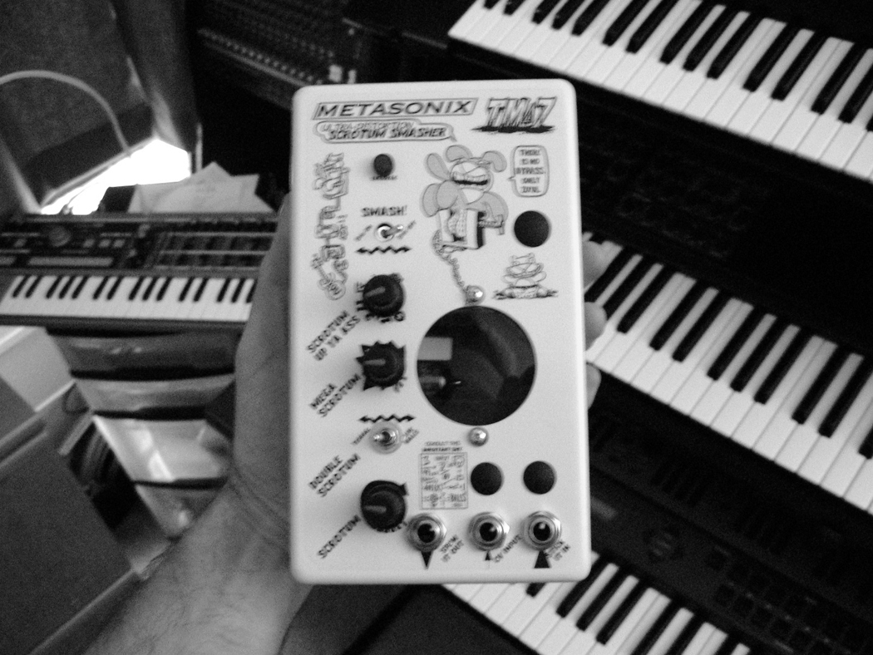
Figure 1: Gently cradling the Metasonix TM-7
(image blurred to recreate realistic drunken euphoric effect on the cradler)

How to connect devices and whatnot to your pedal, and begin the journey that will color your soul a sort of brownish-grey forever and ever: plug your keyboard, guitar, electric zither, 8-track player, or other sound source into where it says "Stick It In." Connect your mixer or sound recording device to where it says "Spew It Out." Don't talk to the nice man in the van, even though the candy looks perfectly safe.

How to connect something via the CV Input patch: plug cable into CV Input patch. Wipe hands on pants.

EXPERIMENT #1:

I have noticed that by applying peanut butter (see figure 2) to the interior of the pedal via the CV Input (see figure 3), that I was able to communicate with my dead grandfather about the whereabouts of his porno zoetrope collection. Afterwards, licking the peanut back out was very rewarding. Please note that this might void your warranty, assuming Mr. Barbour laughably even provided one.

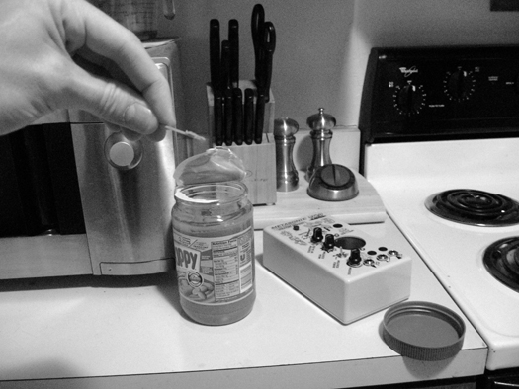
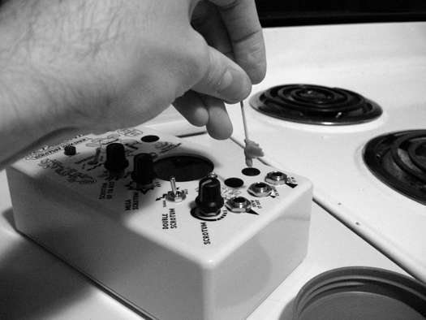
Figure 2: Peanut butter measuring Figure 3: Applying to CV Input

So let's tidy ourselves up mentally, and dig into the functional pinkmeats of this jaundiced morsel of techno-splendor. The actual functionality of an individual knob, switch, lever, and woonsocket (for you Rhode Islanders) can vary dramatically, depending on what everything else is currently set at. For example, "Scrotum Up Ya Ass" might have no effect at all unless "Double Scrotum" is set at a certain point. The best way to familiarize yourself with your TM-7 is via tutorials, in the hope that you might glean the logic and illogic at play.

EXPERIMENT #2: Simple, actually useful distortion with volume control

First, plug in a shiny red keyboard (note: keyboard must be red; see figure 4) the way I've already fucking explained, and initially adjust knobs as follows:

          - Scrotum - all the way up
          - Double Scrotum - set to "Blue Balls"
          - Mega Scrotum - about halfway
          - Scrotum Up Ya Ass - doesn't matter

          - Smash! - BN6 off
Figure 4: Using a red keyboard in a black and white image

Playing a tone will now produce a robust, quaint little distorted process. Adjusting the "Mega Scrotum" knob will turn the volume up and down. Bet you didn't think this manual would actually have any useful information in it, now did you? God damn you and your doubting heart.

Now then... are you ready for the smelliest sound you ever saw? Smash the BN6 on! You will rip open an aperture to Gehenna and unleash at least a dozen 16-hit-dice frost demons. Roll initiative on a 12-sider. Elves, dwarves and halflings must Save vs. Stench Madness due to their acute senses. SNARK! Hey, where am I, I blacked out for a minute there.

EXPERIMENT #3: Distortion brightness control

Keep your current "Scrotum" and "Double Scrotum" settings, leave that BN6 turned on, and turn up both "Mega Scrotum" and "Scrotum Up Ya Ass." You might notice a loud hiss, possibly filtered by a hypnotic pulsation. Not to worry, the TM-7 is supposed to do this. It is merely tuned in to the rhythm of your fading pulse.

What I'd like to dare you to try now is to adjust the "Scrotum Up Ya Ass" knob upsy downsy. Unbelievably, you are now performing another actual useful task: distortion tone modification. Because it's all about "tone" for so many fucking jackoffs, isn't it. All we ever hear about is finding the "perfect TONE, man..." Well, hopefully this will go a long way towards shutting the yaps of those tards.

EXPERIMENT #4: Rip open the time-space continuum and fuck it like it's your sister

Ready for some real fun now? Keep the "Scrotum" turned up, set "Mega Scrotum" about halfway, turn off the BN6, and turn down "Scrotum Up Ya Ass" all the way. Ready? Now switch "Double Scrotum" to "Teabag." Hear that pleasantly awful synthy bass hum? That's you, dude. You're teabagging the universe right now, and it is opening up a supple, moist rift for you to probe. Be careful, because it could turn into a gaping maw full of teeth to clamp down on your nads harder than an insane nun with monkey-like strength.

OK, get ready for some good-time penetration. You don't even have to hold down any notes or 'nuthin. Just turn up the "Scrotum Up Ya Ass" knob. No universe-fuck ever felt quite as good as when your nutsack is inverted four-dimensionally and shoved into your own willing anus. You will become Klein's theoretical paradox decanter, perpetually pouring semen into itself.

It gets better. Playing tones through the unit, while adjusting how far "Up Ya Ass" you're going, will instigate a galactic battle between your tone and the TM-7's self-generating one, causing some rudimentary sync modulations and generally pleasant unpleasantness. Incidentally, additionally adjusting "Mega Scrotum" has the general metaphorical effect of semen regulation. Give it a try.

In the following chart, also depicted conveniently in microscopic size on the front of the unit, you will learn everything else you need to know about both the TM-7 and the rest of the cosmos as well, as luck would have it:
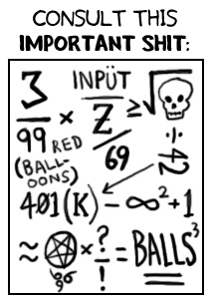
Since you're already on your way to sonically terrifying everyone within earshot, it is now time to explore more practical, real-world applications of the TM-7.

EXPERIMENT #5: Acquire wealth

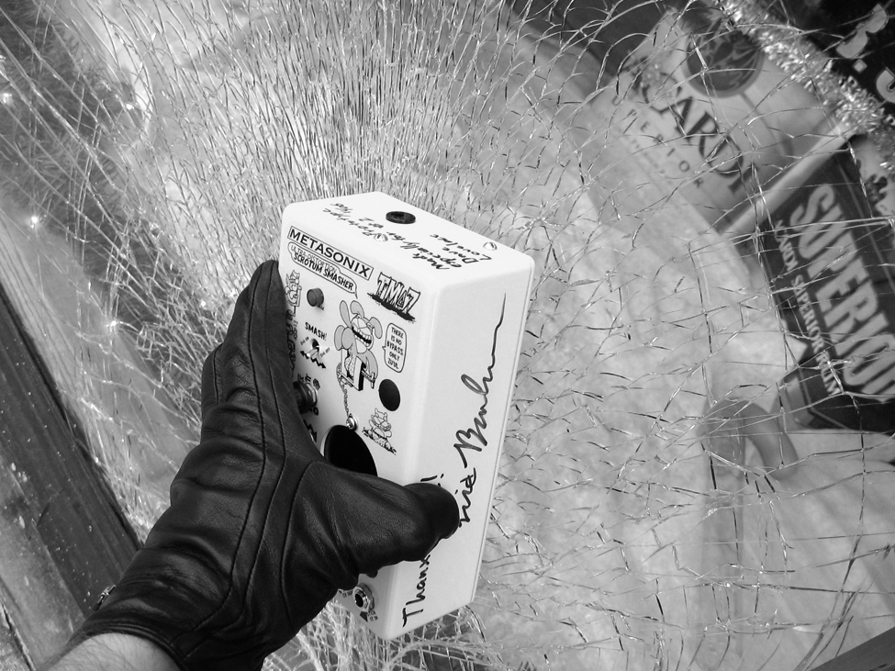
You might notice that Metasonix pedals are brick-like in girth. This is due to the fact that they use good, old-fashioned components that heat up after a bit of use, and take up a lot of room. The other thing is that an amply-weighted cabinet weeds out a lot of pussies. But one of the fringe benefits of this volumetrically advanced enclosure is that it can be used to smash the window of any available liquor store (see figure 5).

Figure 5: Be sure to wear black gloves for safety's sake

As you can probably already guess, getting off your ass, out of the studio, and proceeding forth squintingly into the outside world armed with your trusty TM-7 at hand, you can "signal process" the perception of yourself to others. You can also score some sweet holiday scratch from the coffers of liquor store proprietors, allowing you to purchase many more Metasonix products! You are now at the event horizon of a massive white hole, spouting out more and more possibilities with each successive orbit. Keep smashing windows, keep acquiring wealth, keep purchasing Metasonix products with that wealth to continue the circle with bigger and better heists. With a little perseverance anyone could acquire total control of Earth, and I for one would welcome you as my liege.

Now if you'll excuse me, I will now plug the TM-7 into the Wretch S-1000 as I originally promised earlier in the manual...................

Editor's note: the remainder of Dave's text was an incoherent mess. It can only be assumed that his efforts were a success. For further insight into these experiences, Dave can be reached at St. Anne's Home for the Mentally Raped, Woonsocket, RI.

“Retarded Animal Babies” Cartoons ©2007 David C. Lovelace, all right reserved. Thanx man!
Check out Dave's horrendously offensive animations at umop.com

(text is copyright 2007 Metasonix. All rights reserved. It is a violation of federal law to reproduce, reuse or duplicate this publication without the express written permission of Metasonix or its assigned representative.)

(Oh, you want to FIX it? You say you want a SCHEMATIC?? Oh, that's PRICELESS.
Contact us at METASONIX. PMB 109, 881 11tth Street, Lakeport CA 95453, (707) 263-5343, synth@metasonix.com. We'll arrange for repair, while refusing to give you a schematic. The circuit of this bastard thing is so embarrassing, we didn't write it down anyway.)

